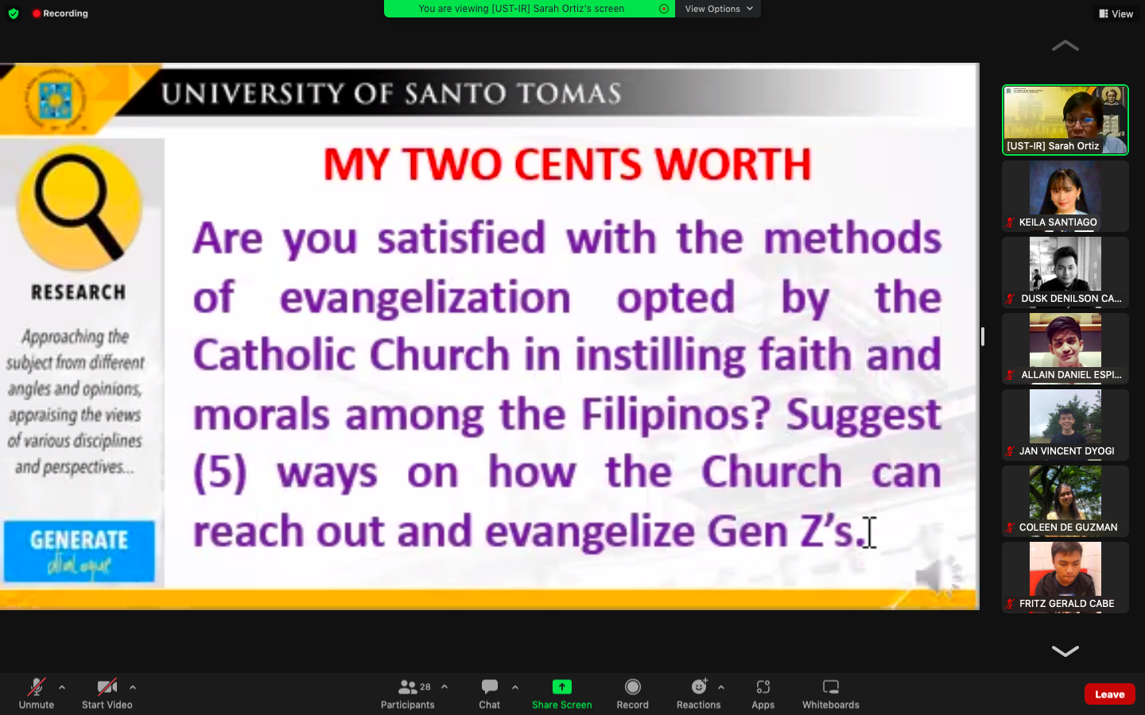

Given the current trends and technologies available at our disposal, the Church can, without a doubt, make improvements and adjustments as to how they currently develop its methods to evangelize and connect with the youth. Gen Z’s early exposure to technology has shaped their view about social issues and religion as they are highly independent and self-directed in their ways.

Living in a country where religion is a part of our culture, we can observe that Filipinos are still very much involved with religious practices. However, some might notice that what is taught inside the church is not exactly being practiced in society itself. In the modern church, there are 5 principles that evangelization can form. **Presence, proclamation, power, persuasion and prophetic.** These 5 serve as the foundation of which modern day evangelization takes place. As our world evolves technologically, so do our methods of evangelization.To effectively reach Gen Z’s, the church can create creative, engaging and informative content through various social platforms to generate enough attention among its target individuals which is the youth. Development of certain applications may also be an option given the rise of demand in terms of the usage of such applications in daily life. Aside from these technological means, The Church may also approach this particular situation with their interests in mind to create a deeper connection with them through varying degrees and forms of interaction. The Church must also be persuasive, yet not aggressive in their approach as Gen Z’s may feel apprehensive about having beliefs pushed upon them. Lastly, the Church must also make use of prophetic evangelism by offering bible studious and religious programs with a twist as this is an effective method to encourage Gen Z’s to believe in the gospel.

Some unique challenges the church faces when trying to reach out and evangelize Gen Zs include the fact that they are more likely to be skeptical of traditional religious institutions, and they are more likely to be interested in spiritual and personal growth than in traditional religious doctrines. Additionally, Gen Zs are often more interested in social media and online communities than in traditional church services, and they are more likely to be skeptical of traditional religious doctrines and practices.  
  
Some specific ways the church can reach out and evangelize Gen Zs include: -Creating a safe and welcoming environment for Gen Zs to come and learn about Christianity -Offering Bible studies and other religious programming that is relevant to Gen Zs -Encouraging Gen Zs to get involved in church activities and ministries -Creating social media and other outreach platforms specifically designed for Gen Zs -Providing resources and support to Gen Zs as they transition into adulthood putek di ko nakita tong nasa baba mb